HAWKES BAY SKI CLUB
hawkesbayskiclub.co.nz

Newsletter May 2017

Another year has rolled around and the first HB snow has fallen so its time to start thinking of the upcoming season. With ongoing temperamental nature of the weather, my highly reliable long term weather forecasters are telling me that this snow season is going to be fantastic.

2017 HANDBOOK
Once again the handbook will no longer be printed and posted out. It will instead be emailed to all members and also be available on the website. It is due to be emailed out in the next week.

LODGE FEES and SUBS PAYMENTS
There has been no changes to any of the fees for 2017, they are to remain the same as 2016 which are:

Lodge Fees: $30/night member
$60 / night visitor

Subs: $220 Ordinary member
$100 Junior Member
$130 Non Active Member

New Member Joining Fee: $172.50 per adult, children free.

The subs invoices have all been sent out so please pay them. Bookings will not be accepted unless subs are paid.

MEMBERSHIP
The club membership is healthy but there is still plenty of capacity for new members so let your skiing buddies know they are more than welcome.

COMMITTEE
The committee for 2017 is:

President - John Mathieson
Treasurer - Brian Usherwood
Secretary - Leah Wilkins
Booking Officer - Christine Osborne
Membership Officer - Reuben Lewthwaite
Club Captain - Joe Moffett
Catering Officer - Di Taylor
Maintenance Officer - Angus Richards

Committee Members
Russell Fergusson
Jay Jones
Pete Richards
Tim Wilkins
Stuart Taylor
Sean Moffett
Shane Kerrisk

BOOKINGS
Get your bookings in now, especially for school holidays. Many people have already started booking. Please remember that bookings will not be considered “confirmed” until the payment is also received.

BOOKING CANCELLATIONS
Over the past few years the club has missed out on income for lodge use due to late cancellations, and not providing enough time for other members to replace the cancellations. We have decided to change the cancellation policy to the following:

Cancellations and refunds– Changes for 2017
- Cancellations must be made by 5.00pm, 4 days prior to occupation to get a refund. For example, if you want to cancel your weekend FRI + SAT night booking you must let the Booking Officer know by 5.00pm Monday.
- If you cancel within the 4 days prior to occupation or don’t turn up or leave early you will still be charged for the duration of your booking.
- Cancellations for the school holidays must be made 5 days before occupation.
- •This policy is the same as most other clubs

This policy is the same as most other clubs

SKI CLUB LOCKERS –2017 applications.
The club has very limited amount of lockers which are available for members use, the locker allocation policy is:
Lockers will only be given to those who apply in writing (either for a new locker or to retain their existing locker) to the club secretary before the 20/6/2017. secretaryhbski@gmail.com

The application must include:
1 – How often you used the club last year
2 – How often you propose to use the club in the coming season
3 – What input you provide to the club outside of general usage
The committee members will consider all applicants and the successful ones will be notified before the start of the season.

NEWS FROM THE MOUNTAIN:
The snowmaking facilities in Happy Valley have been completely overhauled so they can now make snow in warmer temperatures. They are on track to having their earliest ever opening of Happy Valley at Queen’s birthday weekend. Lets hope the rest of the mountain will be soon after that.

The lodge is in great shape and ready to go, get your bookings in soon, and remind your skiing buddies that we are still welcoming new members.

NEWS FROM THE WORKPARTY
Last weekends Working B at the ski club managed to complete the usual preseason stock up and clean, and also get the following R+M done in preparation for the start of the season:
- Repair all the wobbly dining room chairs
- Attempt to repair the Lady Kitchener fireplace which resulted in the decision to remove it and replace it with a new one
- Improve the pressure and replace the mixers in the ladies showers.
- Repair the deteriorating concrete in the front water tank
- Freezer in workshop and lockers outside the workshop swapped location
Many thanks to all those that took part, and like all working B’s, there was a lot of fun had by all.

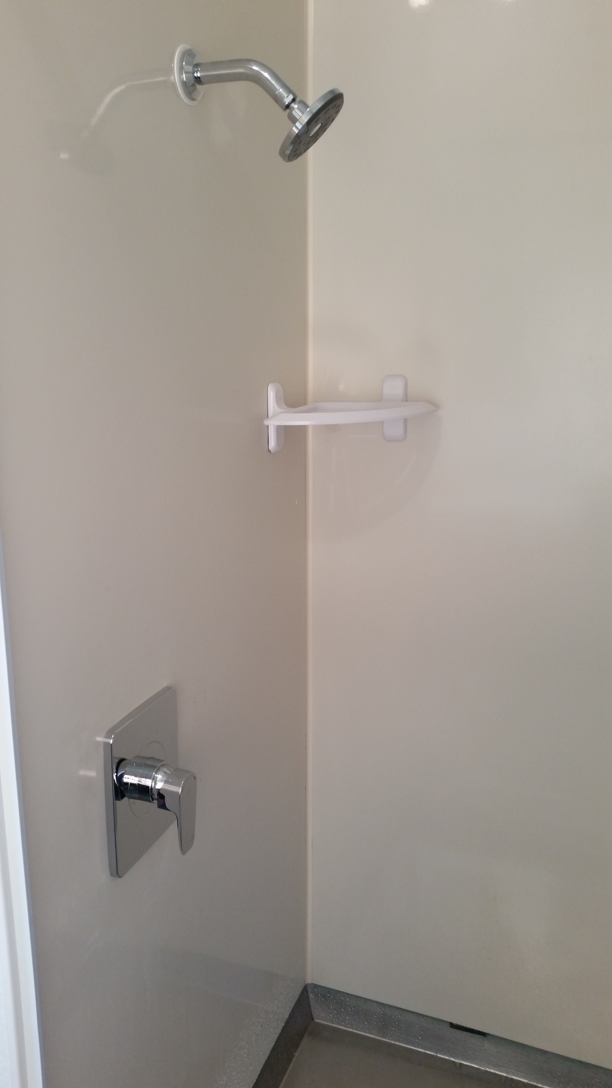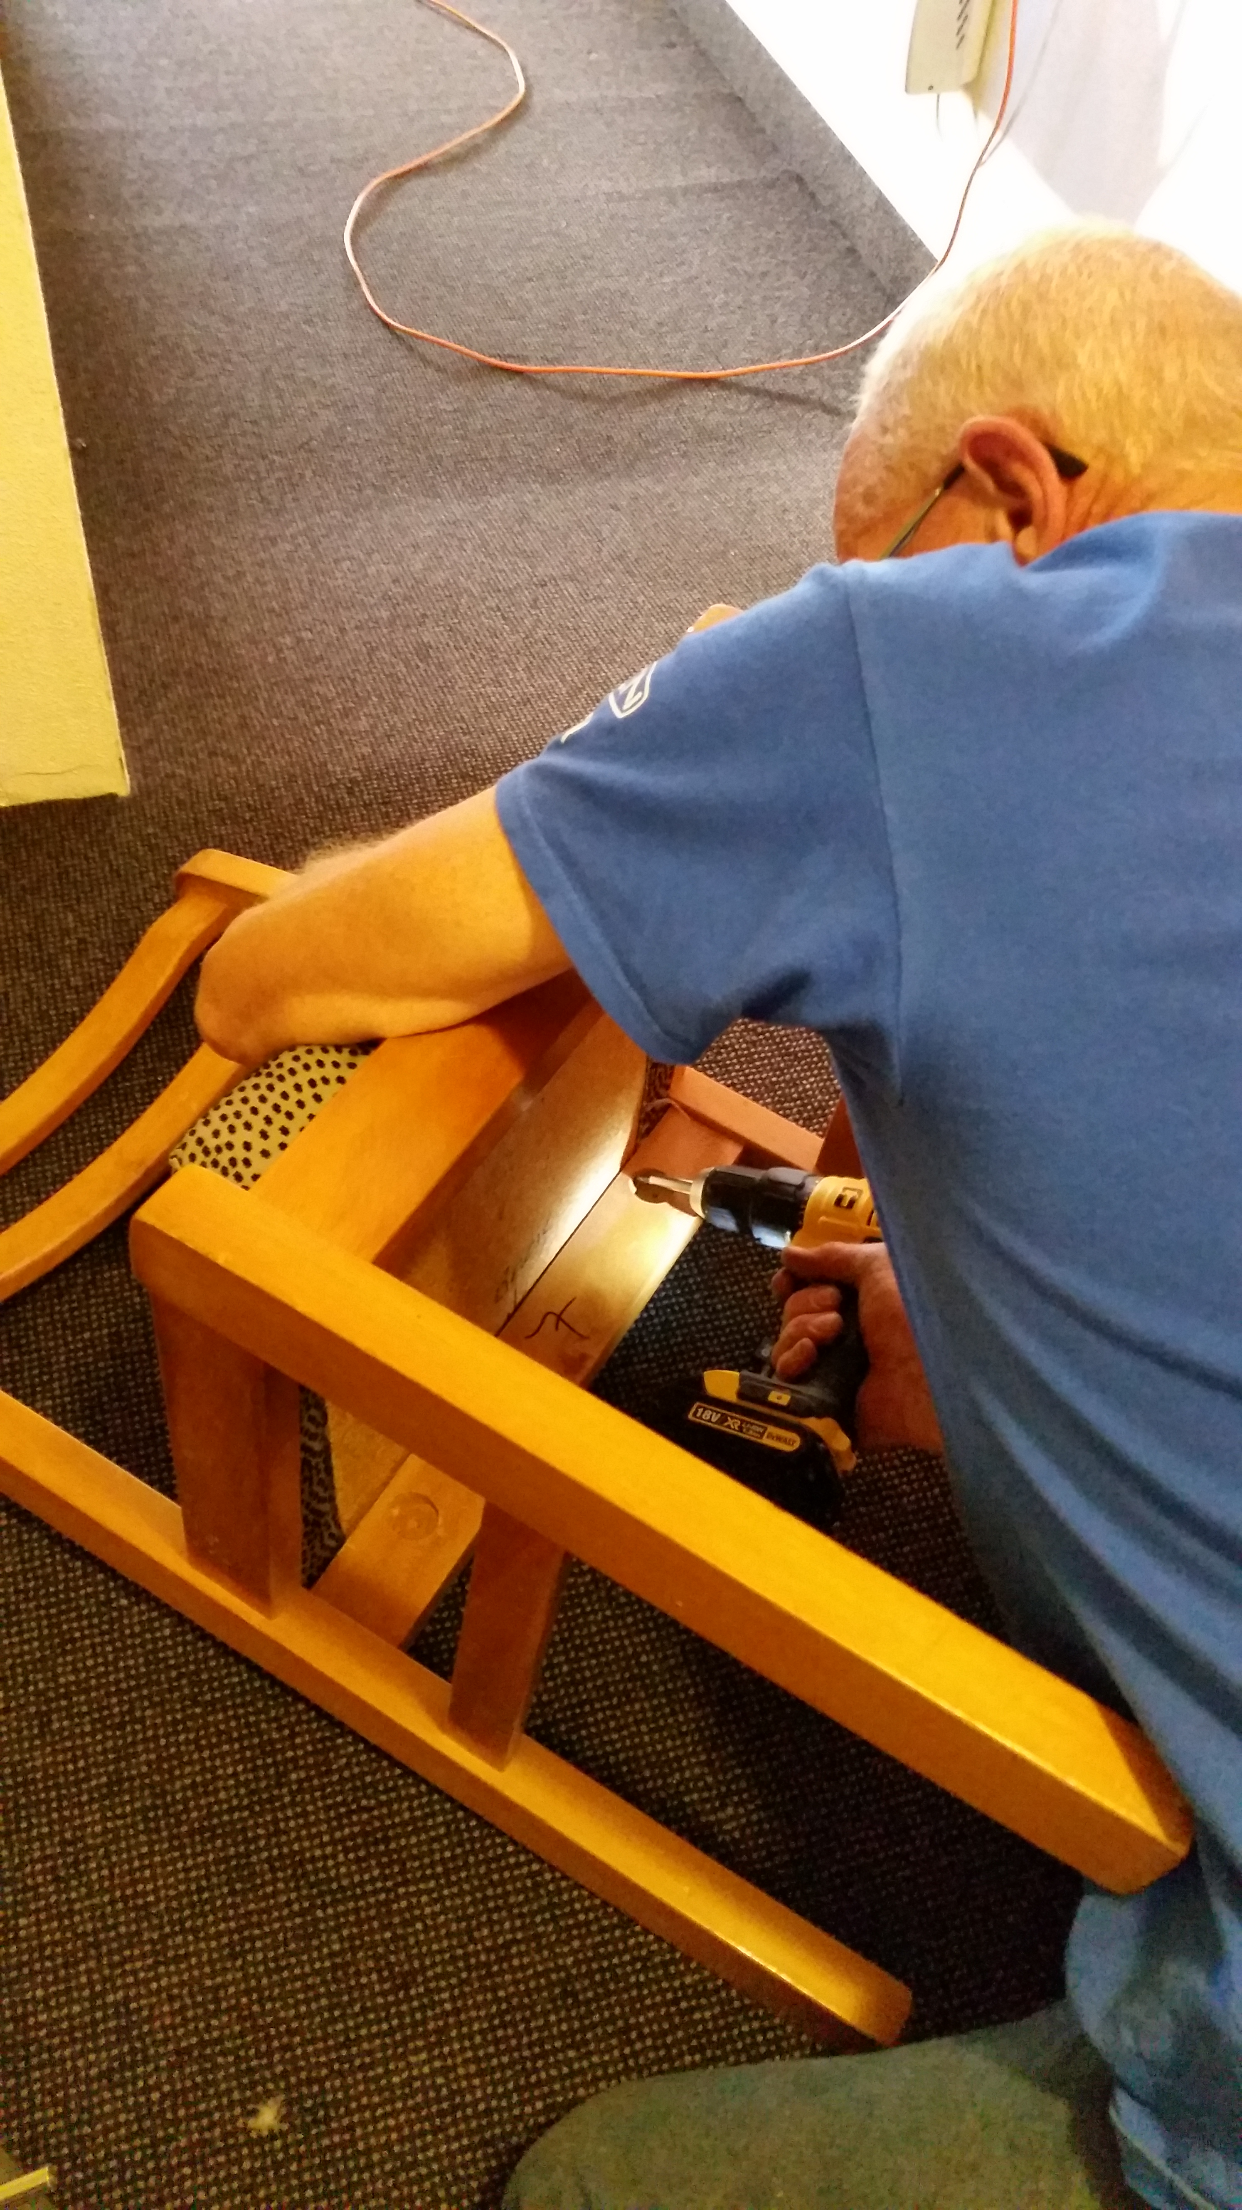
Ladies showers with new mixers Club Predent once again on his hands and knees
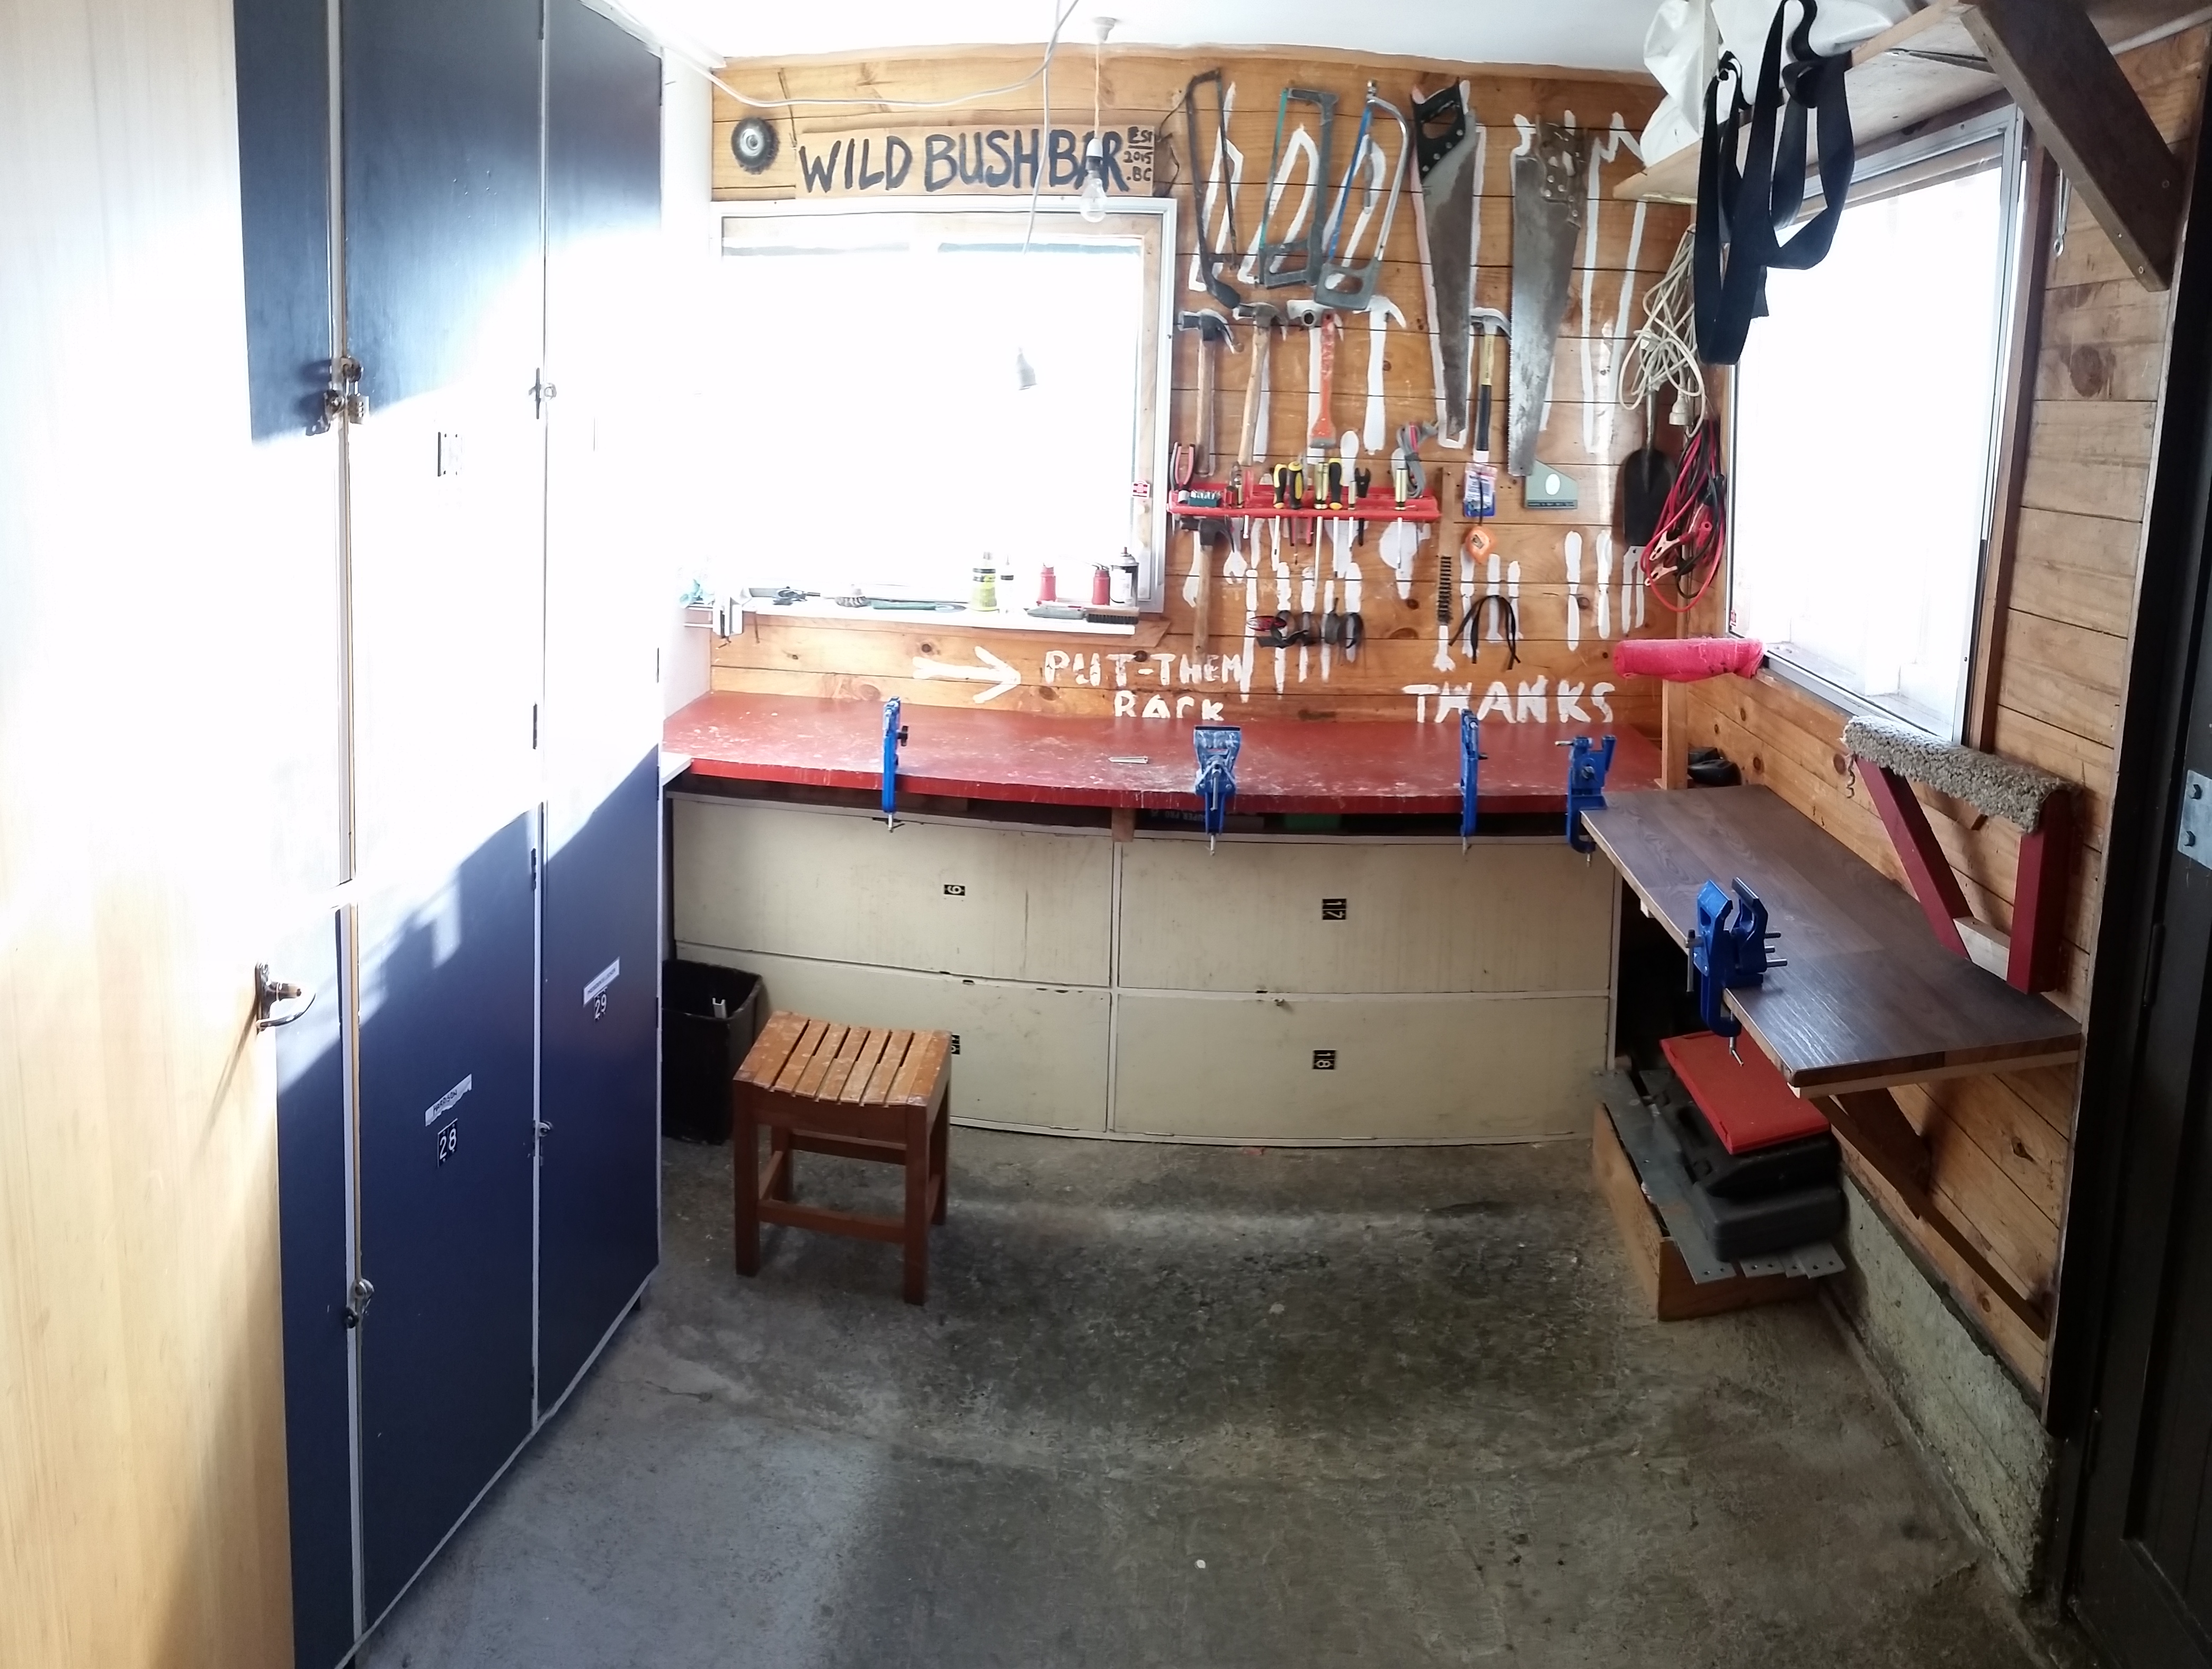
“Spacious Freezerless Workshop”

HAWKES BAY SKI CLUB 2017 CALENDAR
Mon | Tue | Wed | Thu | Fri | Sat | Sun
 |  |  |  |  | 01-Jul | 02-Jul
03-Jul | 04-Jul | 05-Jul | 06-Jul | 07-Jul | 08-Jul | 09-Jul
10-Jul | 11-Jul | 12-Jul | 13-Jul | 14-Jul | 15-Jul | 16-Jul
SCHOOL HOLIDAYS
17-Jul | 18-Jul | 19-Jul | 20-Jul | 21-Jul | 22-Jul | 23-Jul
SCHOOL HOLIDAYS
24-Jul | 25-Jul | 26-Jul | 27-Jul | 28-Jul | 29-Jul | 30-Jul
31-Jul | 01-Aug | 02-Aug | 03-Aug | 04-Aug | 05-Aug | 06-Aug
07-Aug | 08-Aug | 09-Aug | 10-Aug | 11-Aug | 12-Aug | 13-Aug
14-Aug | 15-Aug | 16-Aug | 17-Aug | 18-Aug | 19-Aug | 20-Aug
Whakapapa Ladies Week (One) |  |  | SENIOR WEEK
 |  |  |  |  | HBSC SENIOR RACES
21-Aug | 22-Aug | 23-Aug | 24-Aug | 25-Aug | 26-Aug | 27-Aug
North Island Intermediate yr 7-8 Schools Skip Champs WHAKAPAPA
28-Aug | 29-Aug | 30-Aug | 31-Aug | 01-Sep | 02-Sep | 03-Sep
North Island Primary yr 1-6 Schools Skip Champs - WHAKAPAPA. Whakapapa Ladies Week (Two)
04-Sep | 05-Sep | 06-Sep | 07-Sep | 08-Sep | 09-Sep | 10-Sep
 |  |  |  |  | HBSC JUNIOR RACES
11-Sep | 12-Sep | 13-Sep | 14-Sep | 15-Sep | 16-Sep | 17-Sep
Whakapapa Ladies Week (Three)
18-Sep | 19-Sep | 20-Sep | 21-Sep | 22-Sep | 23-Sep | 24-Sep
North Island Sec Schools Ski Champs - TUROA, Whakapapa Ladies Week (Four)
25-Sep | 26-Sep | 27-Sep | 28-Sep | 29-Sep | 30-Sep | 01-Oct
02-Oct | 03-Oct | 04-Oct | 05-Oct | 06-Oct | 07-Oct | 08-Oct
SCHOOL HOLIDAYS
09-Oct | 10-Oct | 11-Oct | 12-Oct | 13-Oct | 14-Oct | 15-Oct
SCHOOL HOLIDAYS

Start your snow dances,

Joe Moffett – Club Captain

